

**Placement Empowerment Program**

***Cloud Computing and DevOps Centre***

* **Deploy Your Static Website Using GitHub Pages .Host your local Git repository’s static website directly using GitHub Pages.**

Name: Sanjay Raj S Department : IT



**Deploy Your Static Website Using GitHub Pages**

**Prerequisites**

* A GitHub account ([Sign up here](https://github.com/))
* Git installed on your system ([Download Git](https://git-scm.com/downloads))
* A static website (can be built with HTML, Jekyll, Hugo, or Gatsby)

**Step 1: Create a GitHub Repository**

1. Log in to GitHub and navigate to [GitHub Repositories](https://github.com/new).
2. Create a new repository with a relevant name (e.g., my-static-site).
3. Keep it **public** (GitHub Pages does not support private repositories for free accounts).
4. Click **Create repository**.

**Step 2: Initialize a Local Git Repository**

Navigate to your project directory and initialize Git:

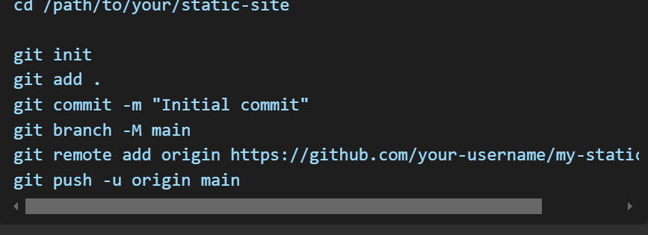

**Step 3: Enable GitHub Pages**

1. Go to your repository on GitHub.
2. Click on **Settings**.
3. Scroll down to the **Pages** section.
4. Under **Source**, select the **Deploy from a branch** option.
5. Choose the main branch and / (root) directory.
6. Click **Save**.

GitHub will now deploy your site, and after a few minutes, your website will be available at:



**Step 4: Automate Deployment with GitHub Actions (Optional)**

Create a GitHub Actions workflow for automatic deployment:

1. Inside your repository, navigate to .github/workflows/.
2. Create a new file deploy.yml.
3. Add the following content

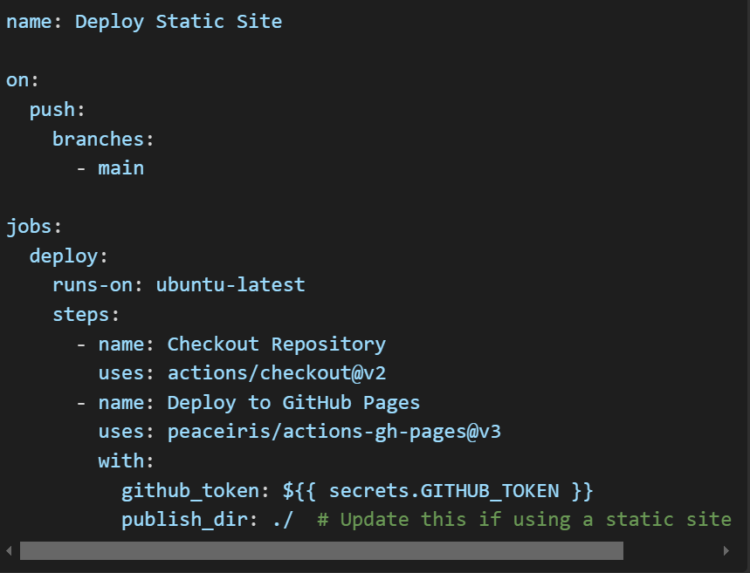

1. Commit and push the changes:



This setup ensures that every push to main automatically deploys your site.

**Conclusion**

You have successfully deployed your static website using GitHub Pages! Your site will be automatically updated whenever you push changes to the main branch. 🚀